Activity 2. 2: Creating a picture
Now you have learnt how to sequence blocks to create a shape, it is time to make a drawing. Use sequencing to program the cat to draw this house:
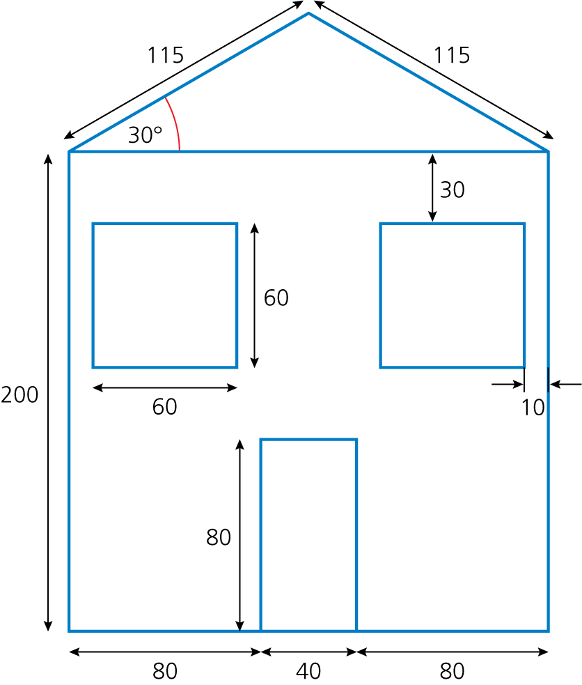

The only new block you will need in addition to those you have already used is this one, the ‘pen up’ block:
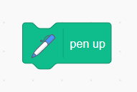

Think about:
- the shapes you need to create
- the dimensions and angles of each shape
- the order in which you are going to create each shape.
Don't forget to screenshot your blocks and paste the screenshot into your evidence document.

